

**پردازش تصاویر دیجیتالی**

**تمرین شماره4**

Morphological Operations

**حسین توکلیان**

**شماره دانشجویی**

**9860571**

خرداد 1399

خانم دکتر عظیمی فر

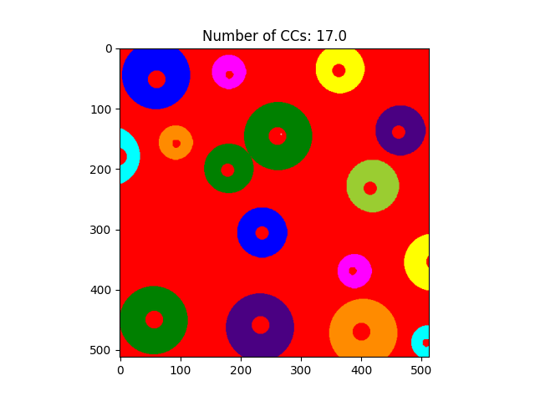

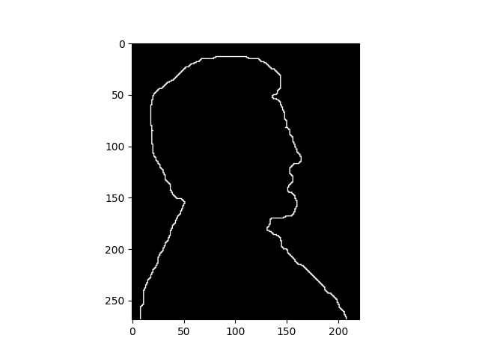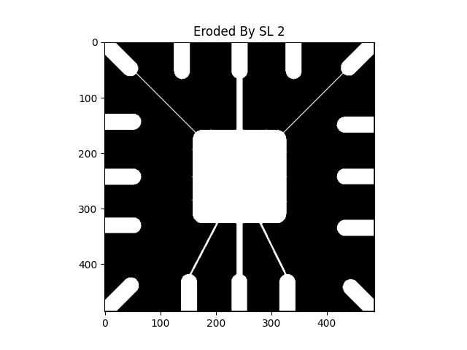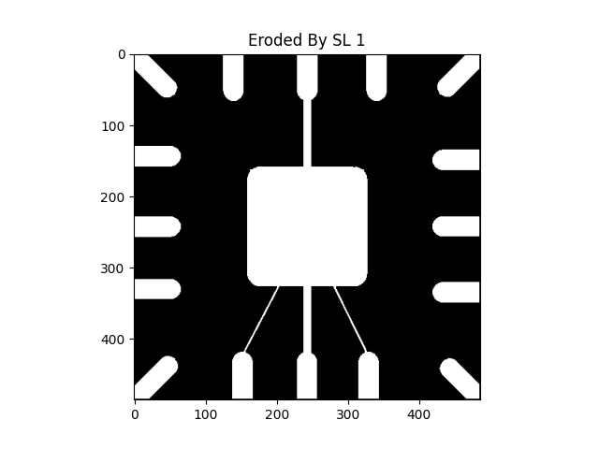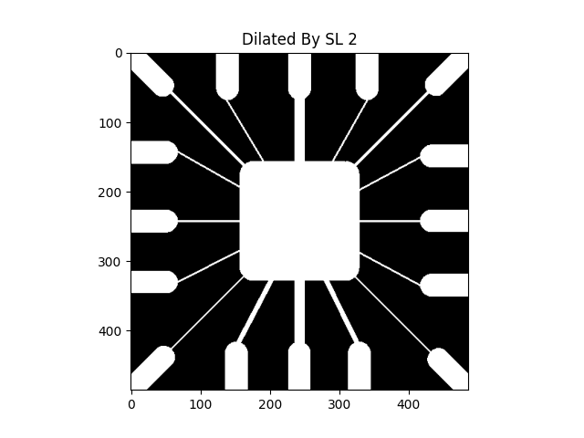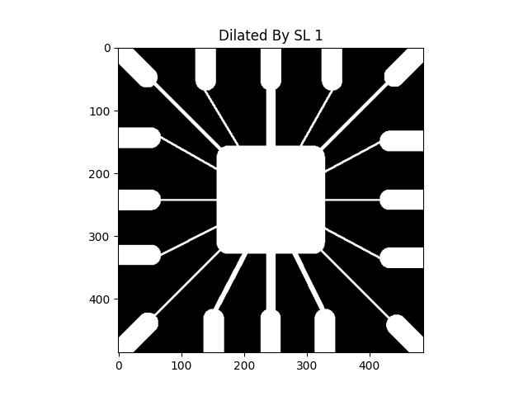

Median filter makes image structure change a lot. A figure below shows the result of applying median filter to a binary image. The small structures, single line, and dot, are removed and small size holes are filled.

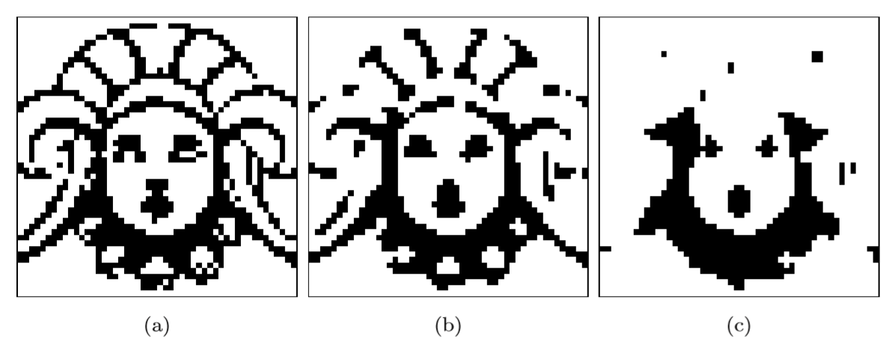

So here is an idea which overcomes this problem. It is called “***Morphological Filter***”.

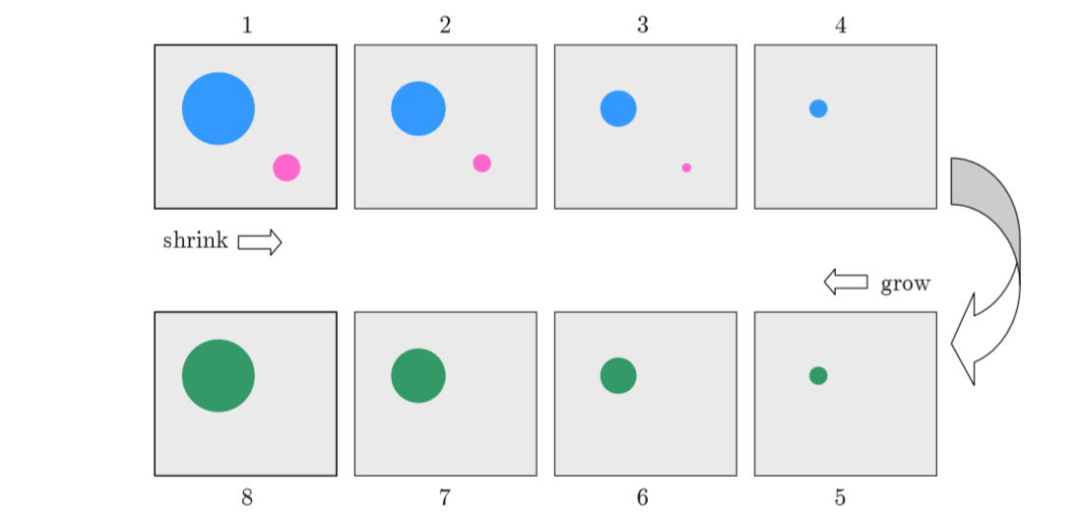

Shrink and grow process

**Morphological Filter**

The idea of the morphological filter are shrink and let grow process. The word “shrink” means using median filter to round off the large structures and to remove the small structures and in grow process, remaining structures are grow back by the same amount.

The morphological operation of the binary image is described first and will talk in the following outline.

**Outlines**

* The structuring element of a binary filter
* Dilation and Erosion
* Composite Operation

**The structuring element**

In morphological filter, each element in the matrix is called “structuring element” instead of coefficient matrix in the linear filter. The structuring elements contain only value 0 and 1. And the hot spot of the filter is the dark shade element.

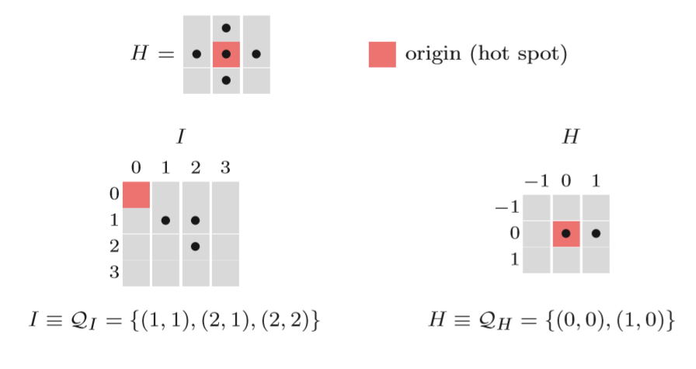

The binary image is described as sets of two-dimensional coordinate point. This is called ***“Point Set”*** Q and point set consist of the coordinate pair p = (u,v) of all foreground pixels. Some operations of point set are similar to the operation in others image. For inverting binary image is complement operation and combining two binary image use union operator. Shifting binary image I by some coordinate vector d by adding vector d to point p. Or reflection of binary image I by multiply -1 to point p.

**Dilation and Erosion**

* ***Dilation*** is a morphological operator which works for the grow process as I mentioned before. The equation of this operator is defined a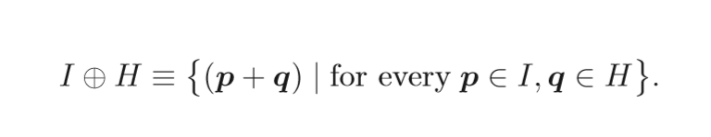
* ***Erosion*** is a morphological operator which works for the shrink process as I mentioned before as well and the equation is defined as

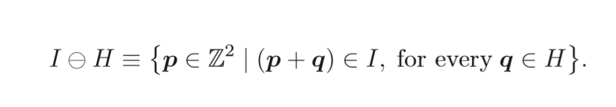

**Properties of dilation and erosion**

* Commutative: only in dilation
* Associative: only in dilation

***Note that:***in erosion is in contrast to dilation, not have commutative property.

In addition, erosion and dilation are ***duels***, for a dilation of the foreground can be accomplished by an erosion of background and subsequent of the result in two different properties but work similarity



**Composite Operation**

In morphological process, dilation and erosion work together in composite operation. There are common way to represent the order of these two operations, opening and closing. Opening denotes an erosion followed by dilation and closing work in opposite way.



Opening and Closing process respectively

The opening and closing also are dual in sense that opening the foreground is equal to closing the background.



Morphological Filter can also apply to gray-scale image, but in the different definition. It is a generalization with MIN and MAX operators. I will describe in following outline.

**Outlines**

* Structuring Elements
* Dilation and Erosion
* Opening and Closing

## Structuring Element

In gray-scale morphology, structuring elements are defined as real-value 2D functions instead of point sets



The value in H can be negative or zero value. But it contrast to linear convolution, zero elements are used to compute the result. And if you do not want to use the elements in some location, you can put no element in that location.

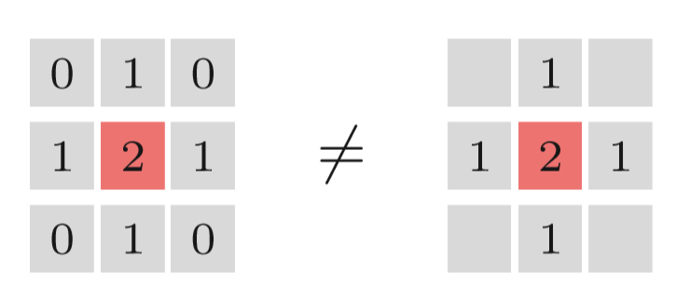

## Dilation and Erosion

The result of dilation and erosion in gray-scale morphology is contributed from maximum and minimum operation.

For dilation, the result is the maximum value of the value in H add to the current sub-image.

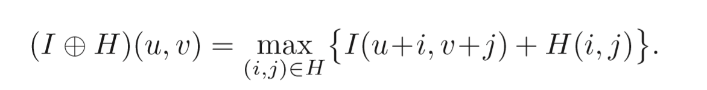

For erosion, the result is the minimum value of the difference.

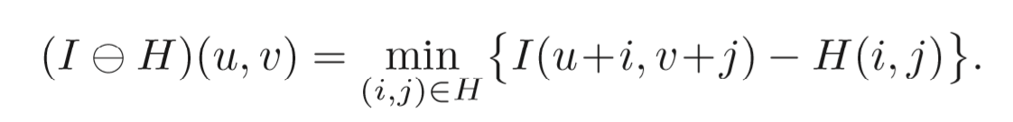

These operations can cause the negative value, so we need to clamping the result after calculation.

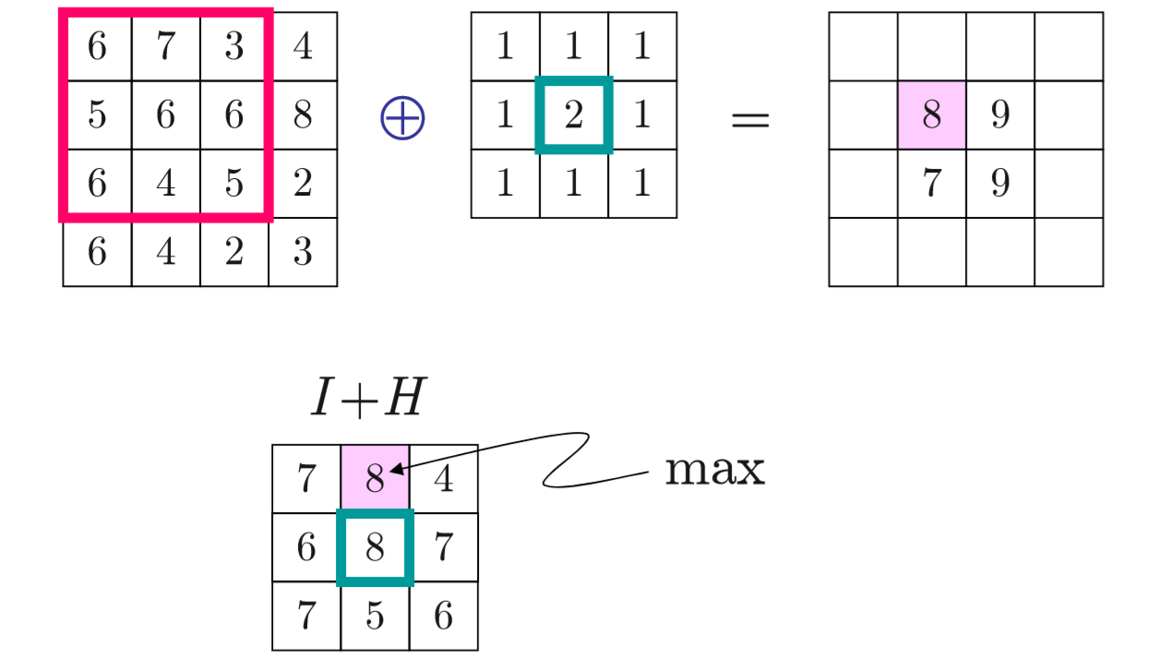

Example of dilation in gray-scale morphology

## Opening and Closing

Opening and closing in gray-scale morphology work in the same way as in binary morphology. The difference is just the operator in dilation and erosion.

For implementation in Python 3 using OpenCV module, you can use the function cv2.erode(input,size) and cv2.dilate(input,size)

This is the result of the program, erosion and dilation, opening and closing.

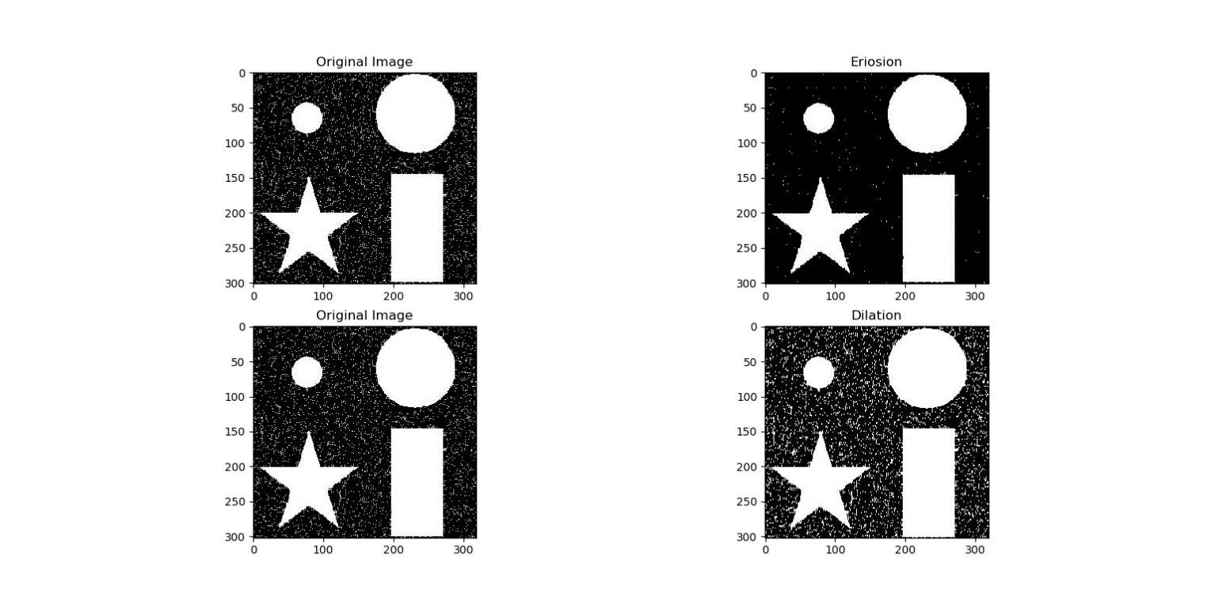

The result of erosion and dilation of the program.

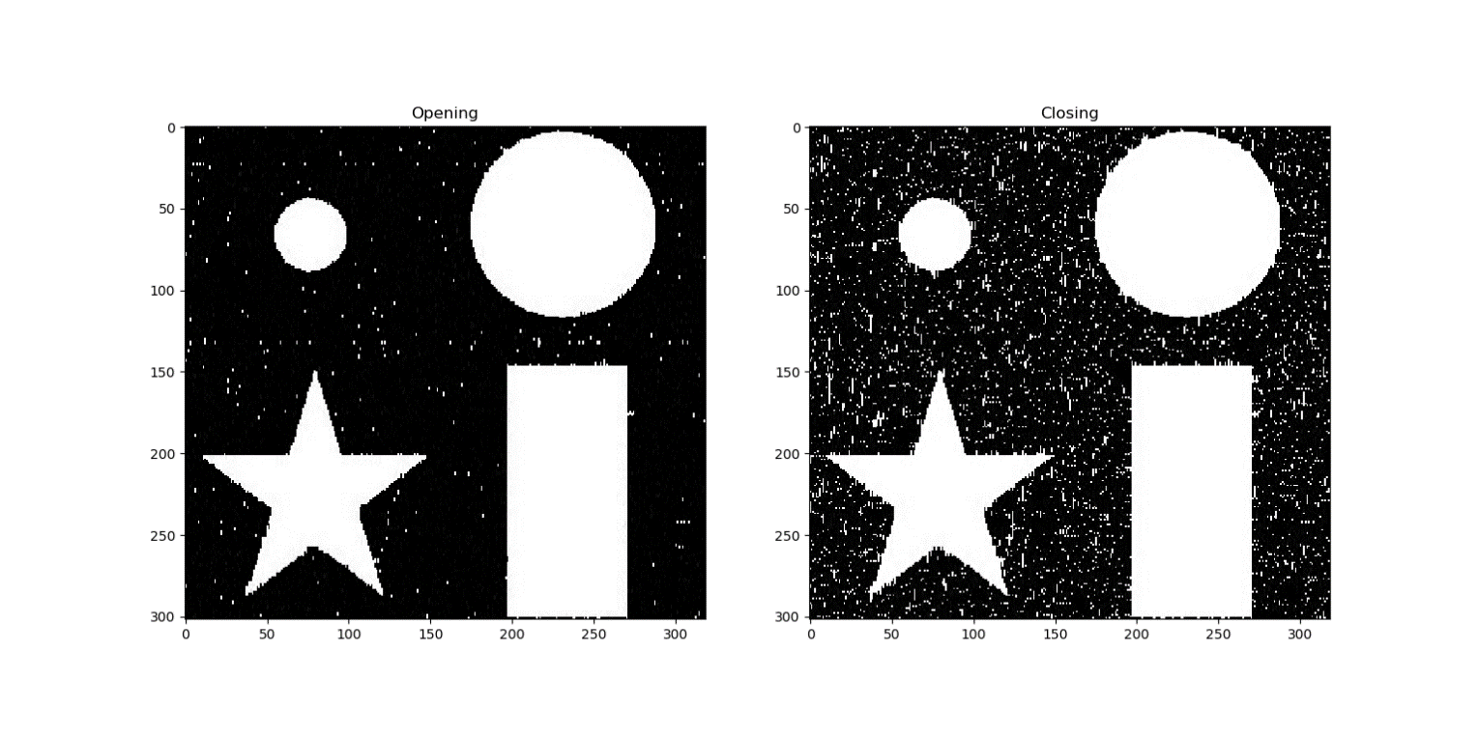

The result of opening and closing from the program.